Ideation Phase
Empathize & Discover

Date | 30 OCT 2025
Team ID | NM2025TMID00011
Project Name | To Supply Leftover Food to Poor
Maximum Marks | 4 Marks

Empathy Map Canvas:
In the Empathize & Discover phase, the team observed how food donors, volunteers and poor people face difficulties in real life. We understood that restaurants and catering places are ready to donate leftover food, but they don’t have time and proper system to give it to the needy people. So the food is wasted. Poor people who really need food are not getting access to these leftover foods.
By talking to stakeholders like hotel owners, mess staff and poor people near public areas, we discovered that the main problem is not food availability, but the lack of a proper connection between donors and receivers. Volunteers also face difficulties because they don’t know where leftover food is available and where to deliver. These insights helped us realize the importance of a simple, quick and real-time system.
Collecting these insights helped the team understand user pain points clearly. Now we know that users need a proper easy-to-use platform that will collect fresh leftover food and deliver it to needy people quickly. These findings will help us build a practical solution which reduces food wastage and hunger at the same time.
Example: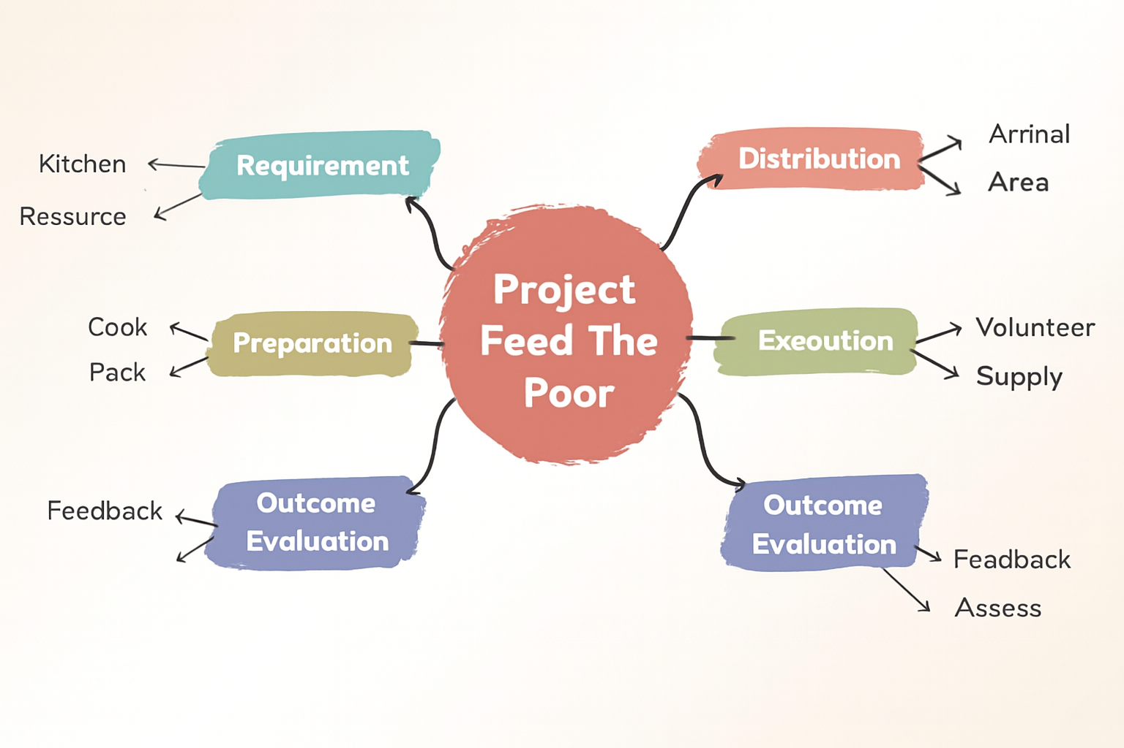

Reference: https://www.mural.co/templates/empathy-map-canvas

The empathy map helped us understand how donors feel sad that fresh food is wasted, volunteers feel confused without proper routes, and poor people feel hungry and worried because they don’t get food regularly. Understanding these real emotions guided us to design a smart leftover food collection and delivery system which is useful, simple and meaningful to society.
Example: Food Ordering & Delivery Application
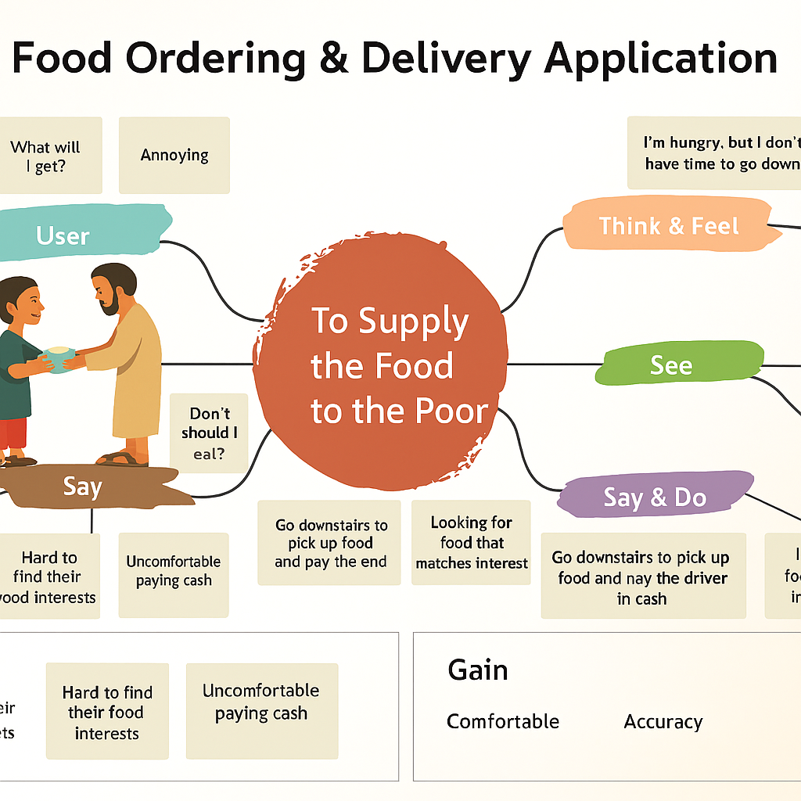
By deeply understanding the users through empathy mapping, we identified the critical problems and frustrations related to leftover food wastage and hunger. These insights revealed pain points such as lack of a proper collection system, no real-time information about food availability, and absence of a structured delivery process. As a result, we planned to design a more intelligent and socially impactful system that connects food donors, volunteers and needy people in real-time. Our system will support location-based pickup, freshness time tracking and safe delivery to receivers. This ensures that leftover edible food reaches poor people before it gets spoiled, thereby reducing food wastage, increasing social responsibility, and helping improve food accessibility for the needy in our society.

